In order to connect to instance we have to open git bash/ putty..etc at the place where .pem file is located

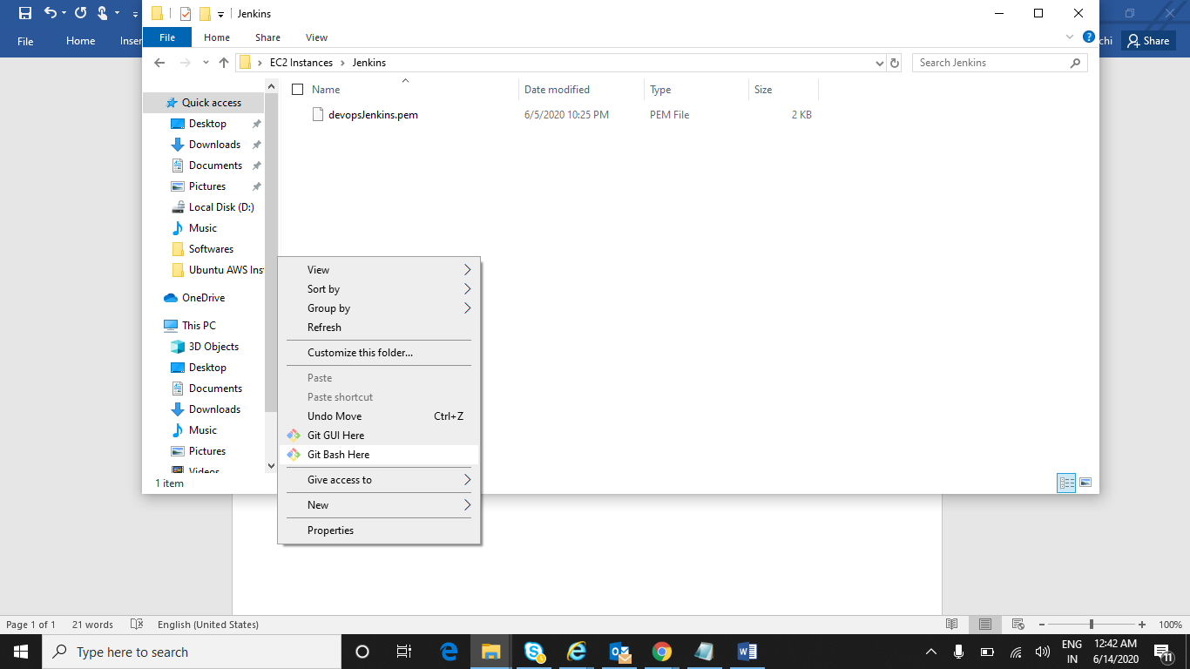

Paste highlighted link into git bash

**ssh -i "devopsJenkins.pem"** [**ubuntu@ec2-100-25-162-29.compute-1.amazonaws.com**](mailto:ubuntu@ec2-100-25-162-29.compute-1.amazonaws.com)

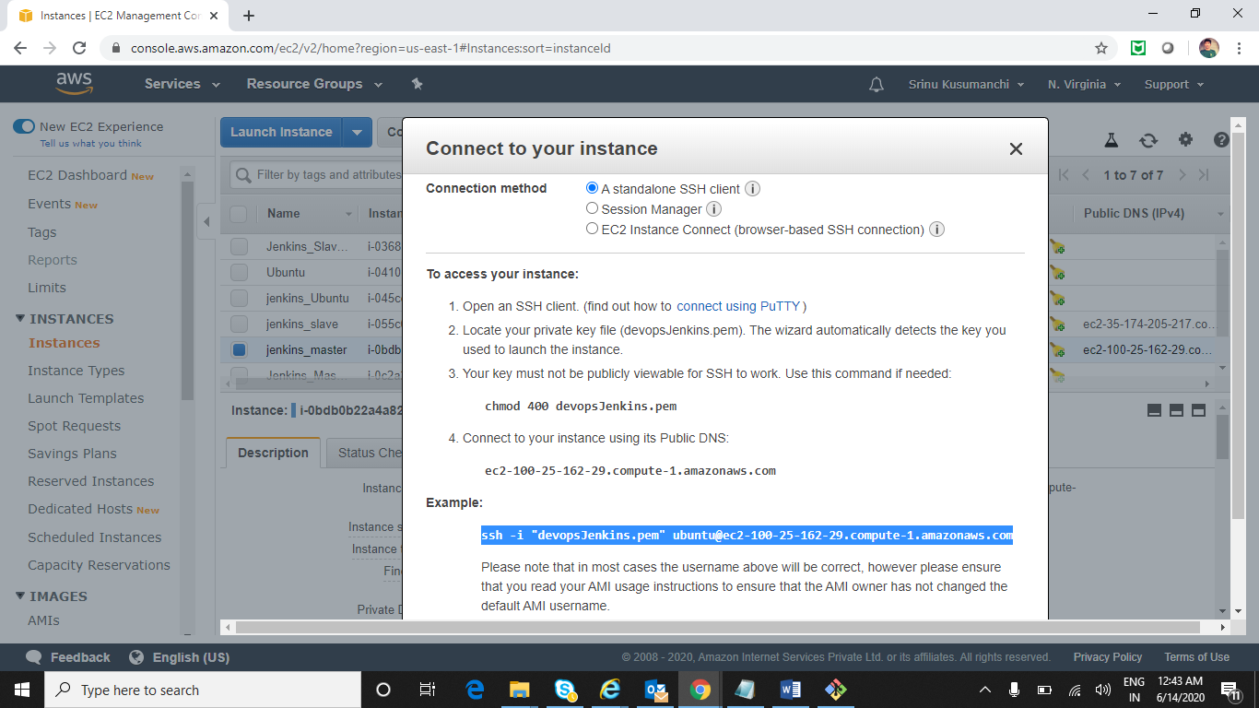

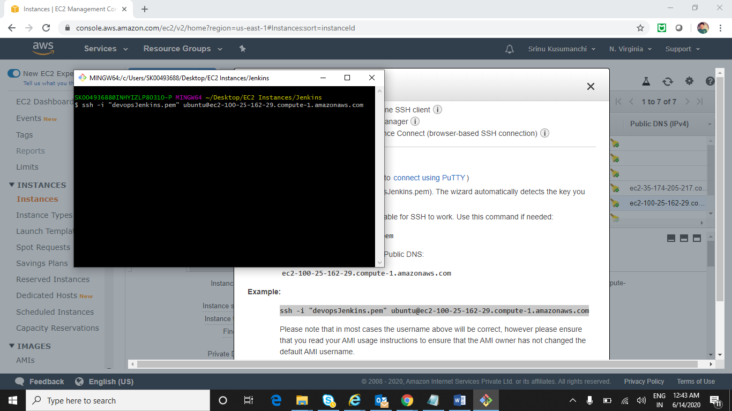

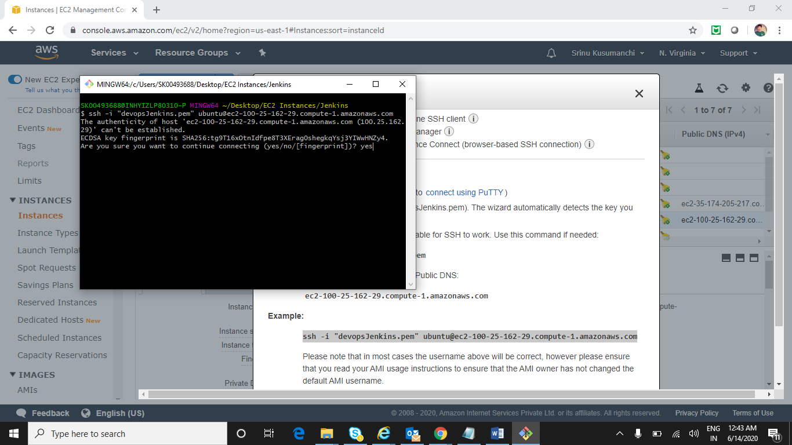

**It is logged into Ubuntu machine**

